WELCOME BACK TO THE GROUP

**Please adhere to the following measures at all times.**

**You must also follow Scottish Government Guidance.**

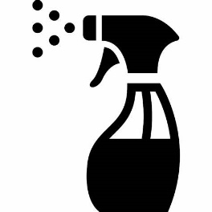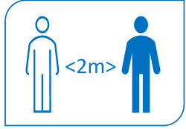

Use the toilet before you leave home

Always maintain physical distancing

Outdoor exercise only

Stay with your own group during a session

Equipment should not be shared and should be cleaned after each use

**Further information and resources can be found in the Covid-19 section of the jogscotland website** <https://jogscotland.org.uk/home/covid-19/>

Group Contact Details

Always follow the leaders instructions